**MISS SHANA & MISS BRANDI**

**NOVEMBER**

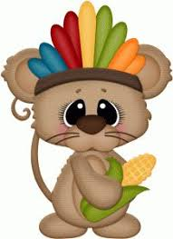

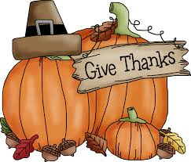

In the month of November, we will be focused on Thanksgiving!

Harvest, Family Gatherings and Being Thankful

We will be introducing the letters X, H and T

REMINDERS:

Please sign your child in and out each day.

Please check your child’s folder on the wall for important papers.

Please label all jackets with your child’s name.

Thank you for your support & kindness! Have a Blessed and Happy Thanksgiving!

IMPORTANT DATES:

Our Election Day bake sale is Tuesday Nov. 5. Any baked goods being donated are needed by Monday Nov. 4th.

**School Closed:**

Nov. 5 – Tuesday Election Day

**School Closed:**

Nov. 27 – Wednesday through

Dec. 2 – Monday (Thanksgiving break)

